
LEN VALLEY PRACTICE

PATIENT INFORMATION
ANI (ACTION NEEDED IMMEDIATELY)

On the 14th January the Safeguarding Minister, Victoria Atkins launched a scheme with independent pharmacies and Boots to launch a Domestic Abuse “ASK for ANI” code word scheme.

From 14th January, victims of domestic abuse will be able to access much needed support from thousands of pharmacies across the UK, backed by the government.

The Ask for ANI (ACTION NEEDED IMMEDIATELY) scheme allows those at risk or suffering from abuse to discreetly signal that they need help and access support. By asking for ANI, a trained pharmacy worker will offer a private space where they can understand the victims needs, to speak to the police or help to access support services such as a national or local Domestic Abuse helpline. The ANI scheme will also provide further vital lifeline for domestic abuse victims trapped by their perpetrators because of COVID. A trip to a participating shop or pharmacy might be a critical opportunity for someone to get help they desperately need.

The Prime Minister recognises that the impact of COVID restrictions and people being asked to “stay at home” means it is vital to take action to protect those for whom home is not a safe space.

This is why he has launched this scheme which is supported by pharmacies up and down the country, to give some of the most vulnerable people in society a critical lifeline, making sure they have access to the support they need and keep them safe from harm.

The scheme will initially be available through the 2,300 Boots stores across the UK as well as 255 independent pharmacies.

For more information about this scheme you can ask either speak to your local Boots pharmacy or any other independent pharmacist locally.

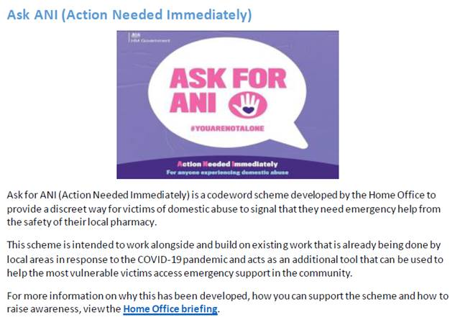

End
Date: 10/2/2021

